**NUTS**

**HERO**



Tree nuts such as almonds, pecans, and walnuts are increasingly recognized for their health benefits and culinary versatility. Flexicon offers a full range of bulk material handling equipment designed to gently convey tree nuts while preserving their quality and minimizing damage throughout processing.

**Button**: Talk To Us

**SHELF #1 - PRODUCT DESCRIPTION**

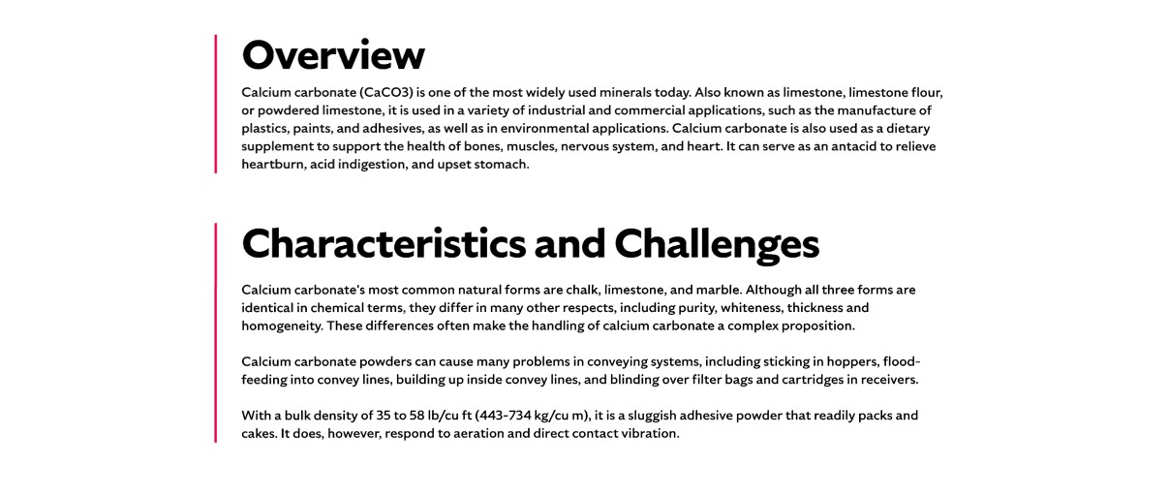



**Overview**Tree nuts have transitioned from being seen as indulgent snacks to becoming staples of a healthy diet, thanks to their rich content of unsaturated fats and essential nutrients. Over the past several decades, U.S. production of almonds, pecans, and walnuts has grown significantly in response to rising consumer demand. These nuts are used in a variety of applications, including whole nut packaging and as ground ingredients in baked goods and snack foods. Flexicon equipment helps meet the needs of this growing industry by preserving product integrity and improving operational efficiency.

**Characteristics and Challenges**Tree nuts like almonds, pecans, and walnuts typically have a bulk density of 30 to 35 lb/ft³ and require gentle handling to preserve their shape and texture. Only about 20 percent of the harvested field weight is usable nut meat, with the rest consisting of debris that must be removed early in processing. Their high oil content can leave residue in conveying systems, necessitating thorough cleanouts between batches. Due to past contamination concerns, regulations now require pasteurization, adding complexity and increasing the risk of damage during handling. Low-speed, gentle conveying is essential to maintain product integrity, especially when using pneumatic systems where air velocity must be carefully controlled to avoid breakage.

Whole nuts are generally free flowing, but ground or sliced nuts can interlock and impede flow, requiring flow-aid devices like agitators or vibrators. Equipment must be abrasion resistant due to the nuts’ texture, and bulk bag dischargers should include features like stretching frames and bag activators to ensure complete emptying. Dust control is critical, with filtration systems and pneumatic pulse cleaners helping maintain sanitation. Flexible screw conveyors should be matched to the nut type, with rounder profiles for whole nuts and flatter spirals for ground varieties. Bulk bag fillers benefit from densification decks and load cells to optimize fill weight and minimize dust during operation.

**SHELF #2 - FLEXICON SOLUTIONS**

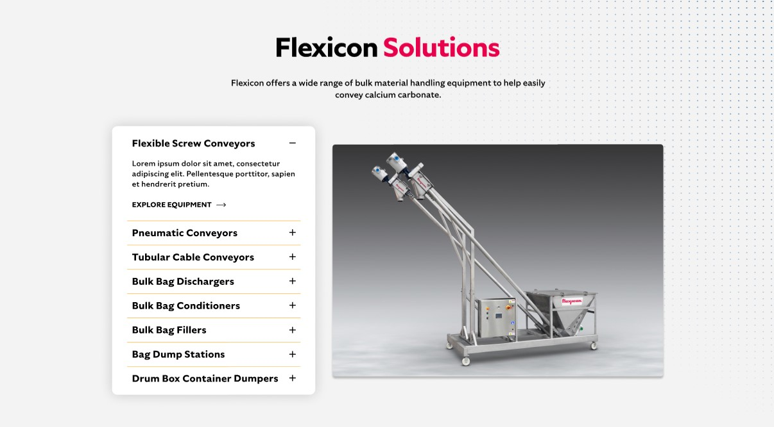

**Flexicon Solutions**

Flexicon offers a wide range of bulk material handling equipment to help easily convey nuts.

**Flexible Screw Conveyors:** Provide gentle, consistent movement of whole or ground tree nuts without causing breakage or separation.

**Pneumatic Conveyors:** Use enclosed airflow systems to transfer nuts cleanly while preserving their shape and minimizing dust.

**Tubular Cable Conveyors:** Transport tree nuts through enclosed tubing with minimal impact, ideal for long or intricate layouts.

**Bulk Bag Dischargers:** Allow secure and dust-controlled emptying of nuts from bulk bags, promoting smooth downstream flow.

**Bulk Bag Conditioners:** Break up hardened or compacted nuts inside bulk bags to ensure reliable and even discharge.

**Bulk Bag Fillers:** Accurately fill bulk bags with tree nuts using vibration and weighing systems to reduce dust and maintain target weight.

**Bag Dump Stations:** Facilitate manual nut unloading with integrated dust collection and ergonomic design for operator safety.

**Drum/Box/Container Dumpers:** Efficiently empty nuts from smaller containers into processing systems while reducing manual handling and airborne particles.

**SHELF #3: LIFETIME PERFORMANCE GUARANTEE**



**Lifetime Performance Guarantee**

All Flexicon equipment and systems are backed by a lifetime performance guarantee. In the rare event that our product fails to meet your performance standards, we will provide the necessary repairs or replacements to keep your conveying line running.

**SHELF #4: CASE STUDIES**

